**FRONT END WEB DEVELOPMENT WITH REACT.JS**

1. **INTRODUCTION:**

* **Project Title:** Cryptoverse – A cryptocurrency dashboard
* **Team Members:**

1. Lishanika. S - lishanikas-cswithai@srmasc.ac.in
2. Shanmuga Priya. J – shanmugapriyaj-cswithai@srmasc.ac.in
3. Rajeshwari. R – rajeshwarir-cswithai@srmasc.ac.in
4. Indhumathy. R – indhumathyr-cswithai@srmasc.ac.in
5. Sanjai. T – sanjait-cswithai@srmasc.ac.in
6. **PROJECT OVERVIEW:**

* **Purpose:**

Cryptoverse is a cryptocurrency dashboard project designed to provide real-time data, insights, and analytics on digital assets. It serves as a comprehensive platform for tracking live prices, market trends, and historical data, helping users stay informed about the dynamic crypto market. The project also includes portfolio management features, allowing users to monitor and analyze their holdings efficiently. Additionally, Cryptoverse aggregates news and industry updates to keep users aware of important developments. With a user-friendly and interactive interface, it caters to both beginners and experienced traders, enabling data-driven decision-making in the fast-paced world of cryptocurrency.

* **Features:**
* **Real-Time Market Data** – Live price tracking, market trends, and historical data analysis.
* **Portfolio Management** – Monitor and analyze personal cryptocurrency holdings.
* **Interactive Charts & Graphs** – Visual representation of market trends for easy analysis.
* **Search & Filtering** – Quickly find and compare specific cryptocurrencies.
* **User-Friendly Interface** – Clean, intuitive design suitable for all experience levels.

1. **ARCHITECTURE:**

* **Component Structure:**
* The **App component (App.js)** serves as the root of the application. It handles routing using **React Router** and manages global state via **Context API or Redux**. It also renders key layout components like the **Header, Sidebar, and Footer**, ensuring consistent user experience across all pages.
* The **layout components** include the **Header** (with a search bar and user settings), **Sidebar** (for navigation), and **Footer** (for additional links and copyright info). These components are persistent across the app and allow seamless navigation between different sections.
* The **main pages** include **Home, Markets, Portfolio, and News**, each corresponding to a route. The **Home page** provides an overview of trending cryptocurrencies and market stats. The **Markets page** displays real-time price data using a table or grid. The **Portfolio page** allows users to track their holdings and calculate profit/loss. The **News page** aggregates and presents the latest cryptocurrency-related news.
* The **API service (api.js)** manages data fetching from external sources like **CoinGecko or CoinMarketCap**. State management is handled via **Context API or Redux**, storing data such as user portfolios, preferences, and theme settings.
* All components interact seamlessly to provide an intuitive and responsive dashboard. This modular structure ensures easy scalability, allowing future enhancements like authentication, dark mode, and real-time WebSocket price updates.
* **State Management:**

Cryptoverse uses **Context API or Redux** for state management, ensuring efficient data flow across components. The **global state** stores user preferences, portfolio data, and theme settings, making them accessible throughout the app. Context API is ideal for lightweight state needs, while Redux is used for complex state logic, such as managing user portfolios and API-cached market data. The state is structured into **reducers and actions**, ensuring updates are predictable and maintainable. Additionally, **React Query** or **local storage** may be used for caching frequently accessed data, reducing API calls and improving performance.

* **Routing:**

Cryptoverse uses **React Router** for client-side navigation, enabling a seamless, single-page application experience. It defines routes for key pages like **Home (/), Markets (/markets), Portfolio (/portfolio), and News (/news)**, ensuring efficient rendering without full-page reloads. The <Routes> and <Route> components manage page switching, while **useNavigate** and **Link** handle programmatic and user-driven navigation. React Router also supports **dynamic routes** and **protected routes** for future authentication features.

1. **SETUP INSTRUCTIONS:**

* **Prerequisites:**
* React
* React Router
* Redux Toolkit / Context API
* Axios / Fetch API
* CoinGecko API / CoinMarketCap API
* Jest / React Testing Library
* **Installation:**

1. Clone the Repository
2. Install Dependencies
3. Configure Environment Variables
4. Start the Development Server
5. Open in Browser
6. **FOLDER STRUCTURE:**

* **Client:**

The Cryptoverse React application follows a well-structured folder organization for maintainability and scalability. The **src/** directory contains key folders like **components/**, which houses reusable UI elements such as buttons, charts, and cards. The **pages/** folder includes main views like Home, Markets, Portfolio, and News, each representing a route. The **assets/** folder stores images, icons, and styles, while **utils/** contains helper functions for formatting and API calls. The **context/** or **redux/** folder manages global state, and **services/** handles API interactions. Routing logic is managed inside **App.js**, ensuring a modular and clean architecture.

* **Utilities:**

Cryptoverse includes several **helper functions, utility classes, and custom hooks** to streamline functionality and improve code reusability. The **utils/** folder contains helper functions like formatCurrency() for formatting prices, convertTimestamp() for date conversions, and calculatePercentageChange() for market trend analysis. Custom hooks, such as useFetchData(), simplify API calls by handling fetching, loading states, and error management, while useLocalStorage() manages persistent state for user preferences. Utility classes for theme management and reusable styling ensure a consistent UI. These utilities enhance efficiency, reducing redundant code and improving maintainability.

1. **RUNNING THE APPLICATION:**

To start the Cryptoverse frontend server locally, navigate to the project folder and run:

npm start # For NPM users

or

yarn start # For Yarn users

This will launch the development server at **http://localhost:3000**, allowing you to preview the application in your browser.

1. **COMPONENT DOCUMENTATION:**

* **Key Components:**
* **App.js** – The root component handling routing and global state. No props.
* **Header.js** – Displays the logo, search bar, and user settings. Receives onSearch for search input handling.
* **Sidebar.js** – Navigation menu for switching between pages. Accepts activePage to highlight the current section.
* **CryptoCard.js** – Displays cryptocurrency details like name, price, and change. Props: coinData (crypto details object).
* **PortfolioItem.js** – Shows user portfolio holdings. Props: coin, quantity, and onRemove.
* **Reusable Components:**

Cryptoverse includes several **reusable components** to maintain a modular and efficient codebase. The **Button.js** component provides a customizable button with props like label, onClick, variant (primary/secondary), and disabled. **CryptoCard.js** is used across pages to display cryptocurrency data, accepting coinData as a prop containing name, price, and percentage change. **Chart.js** renders interactive price trends using data (historical prices) and coinName for dynamic updates. **SearchBar.js** is a reusable input field with onSearch and placeholder props, used for filtering cryptocurrencies or news. **NewsCard.js** standardizes news article display, taking title, source, publishedAt, and url. These components enhance maintainability, ensuring consistency and reusability across the application.

1. **STATE MANAGEMENT:**

* **Global State:**

Cryptoverse uses **Redux Toolkit** or **Context API** for global state management, ensuring seamless data flow across the application. The global state stores essential data such as **market prices, user portfolio, theme preferences, and API responses**. The **state flows** from a central store (Redux) or provider (Context API), allowing components to access and update data efficiently. For example, the **Portfolio page** retrieves stored holdings, while actions like adding or removing a cryptocurrency dispatch updates to the state. The **Markets and Home pages** fetch live data, caching responses for performance optimization. Components subscribe to relevant slices of the global state via useSelector() (Redux) or useContext() (Context API), ensuring reactive UI updates. This structured approach enhances scalability and maintainability.

* **Local State:**

Cryptoverse handles **local state** within components using **React's useState hook** for managing UI-specific data that doesn’t need to be global. Local states are used for interactive elements like **search inputs, modal visibility, form inputs, and loading states**. For example, in SearchBar.js, const [query, setQuery] = useState('') manages the search input value, updating as the user types. Similarly, Modal.js uses const [isOpen, setIsOpen] = useState(false) to toggle visibility. Components pass setter functions (setState) as props to child components when updates are required from within. This ensures efficient rendering, reducing unnecessary global state complexity while keeping UI interactions smooth and responsive.

1. **USER INTERFACE:** 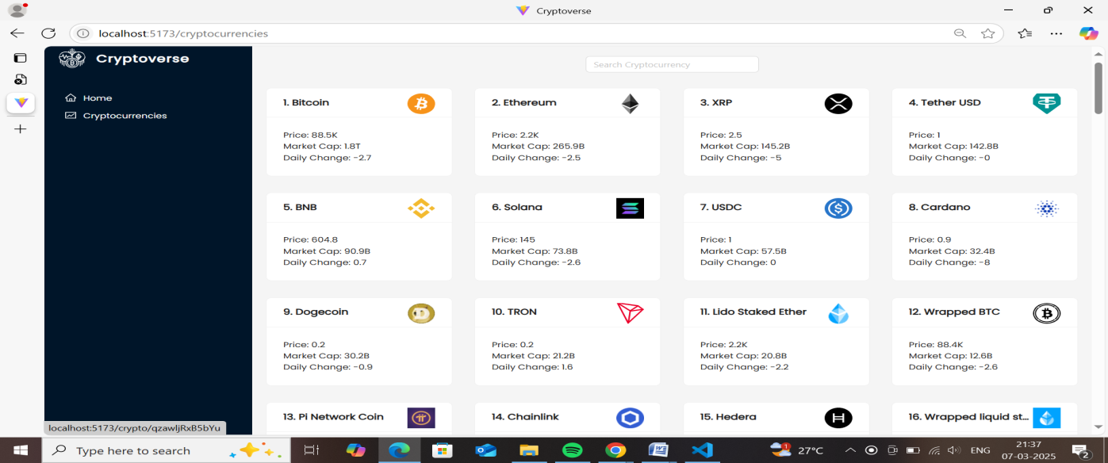
2. **STYLING:**

* **CSS Frameworks/Libraries:**

Cryptoverse uses **Tailwind CSS** for utility-first styling, allowing rapid and responsive UI development without writing extensive custom CSS. It provides predefined classes for layout, spacing, colors, and typography, ensuring a clean and consistent design. Additionally, **Styled-Components** or **CSS Modules** may be used for scoped component-level styling, preventing global style conflicts. For complex UI elements like modals and buttons, **Material-UI (MUI)** or **ShadCN/UI** can be integrated for pre-styled components with customization options. If animations are needed, **Framer Motion** enhances UI interactions with smooth transitions. This approach ensures a scalable, maintainable, and visually appealing user interface.

* **Theming:**

Cryptoverse follows a **custom design system** built primarily with **Tailwind CSS** to ensure consistency and scalability across the UI. The design system defines a **global color palette**, typography styles, spacing rules, and reusable UI components like buttons, cards, and modals. Additionally, **utility classes** and **CSS variables** help maintain a consistent theme, including support for **light and dark modes**. If needed, a **custom component library** using **Styled-Components or ShadCN/UI** can be implemented to ensure uniform design patterns. This structured approach enhances maintainability, improves user experience, and allows easy theming and future updates.

1. **TESTING:**

* **Testing Strategy:**

Cryptoverse follows a **comprehensive testing approach** covering **unit, integration, and end-to-end (E2E) testing** to ensure reliability. **Unit tests** are written using **Jest and React Testing Library**, focusing on individual components like CryptoCard and SearchBar, testing their rendering, props, and event handlers. **Integration tests** validate interactions between components, such as ensuring the MarketTable correctly updates when filtering data. For **E2E testing**, tools like **Cypress or Playwright** simulate real user workflows, such as searching for a cryptocurrency, adding it to a portfolio, and verifying state updates. Mocks and stubs are used to simulate API calls, ensuring fast and isolated tests. This structured approach guarantees a stable and bug-free application.

* **Code Coverage:**

Cryptoverse ensures **adequate test coverage** using **Jest** and **React Testing Library** for unit and integration tests, along with **Cypress** for end-to-end testing. **Coverage reports** are generated using Jest’s built-in **--coverage** flag, identifying untested code areas. **Mocking API calls** with tools like **MSW (Mock Service Worker)** prevents external dependencies from affecting test reliability. **Snapshot testing** ensures UI consistency, detecting unintended component changes. **CI/CD pipelines** (GitHub Actions or GitLab CI) run automated tests on every commit, preventing regressions. This approach ensures robust test coverage, improving application stability and maintainability.

1. **SCREENSHOTS OR DEMO:**

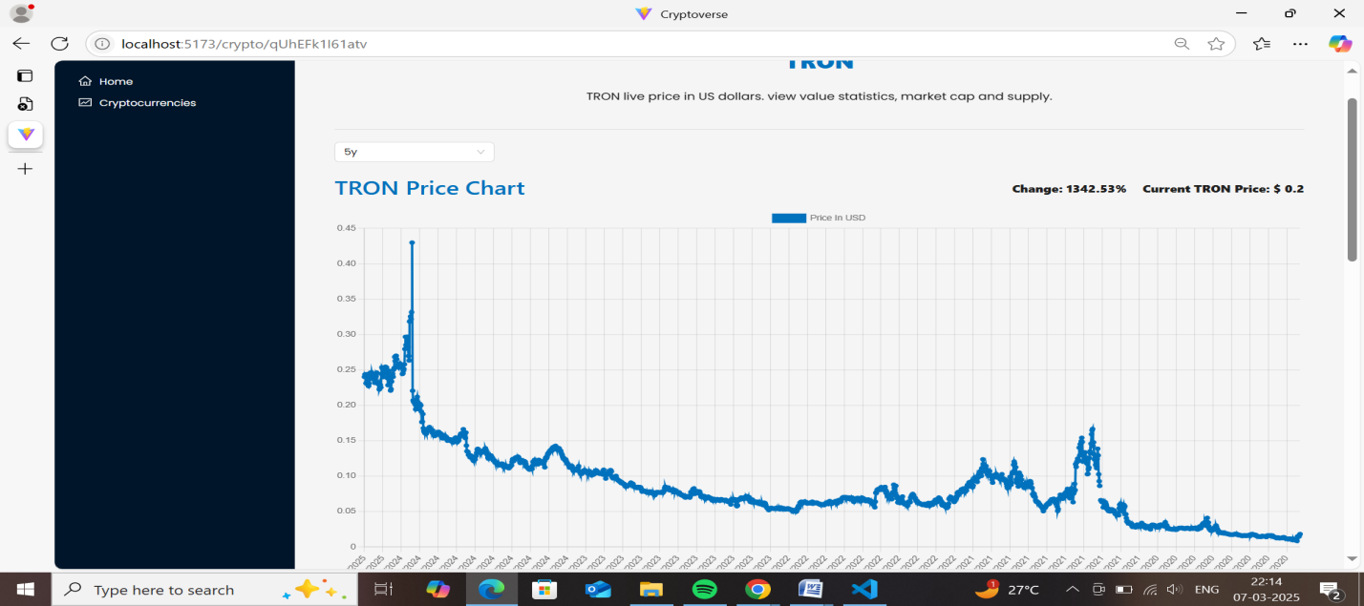

1. **KNOWN ISSUES:**

* **Delayed API Responses** – Occasionally, cryptocurrency data fetches may be slow due to third-party API rate limits.
* **Inconsistent Data Updates** – Market prices may not refresh in real-time without manually reloading the page.
* **Dark Mode Glitches** – Theme settings may not persist correctly across sessions in some browsers.
* **Search Function Lag** – Searching for cryptocurrencies can experience slight delays when handling large datasets.

1. **FUTURE ENHANCEMENTS:**

**Crytoverse** could include multi-chain integration for seamless interoperability, AI-powered analytics for market predictions, and advanced security with biometric authentication. Expanding into the NFT and metaverse space, it could offer virtual real estate trading and enhanced NFT utilities. DeFi features like yield farming and decentralized lending could boost financial inclusion. Improved UX with gamification and real-time notifications would enhance user engagement. Lastly, regulatory compliance and DAO-based governance could ensure transparency and long-term sustainability.